Part-D (Delivery Delay)

Analysis of Current Model Results:-
- Delivery Delay and Order Fill Rate

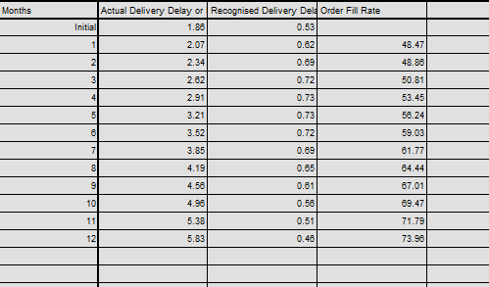

This will show how delivery delays (actual and perceived) evolve with the order fill rate, highlighting the lag in customer perception (due to the 4-month smoothing) and its potential impact on orders.

- Recognised Delivery Delay decreasing from 0.53 to 0.46 months contradicts the reality, where it should increase with a 4-month smoothing period (e.g., 4 months by Month 12, lagging Actual Delivery Delay).
- While Actual Delivery Delay increases significantly (from 1.86 to 5.83 months), Recognised Delivery Delay peaks at 0.73 months and then drops to 0.46 months
- Order Fill Rate grows by from 48.47 to 73.96, but Actual Delivery Delay still increases.

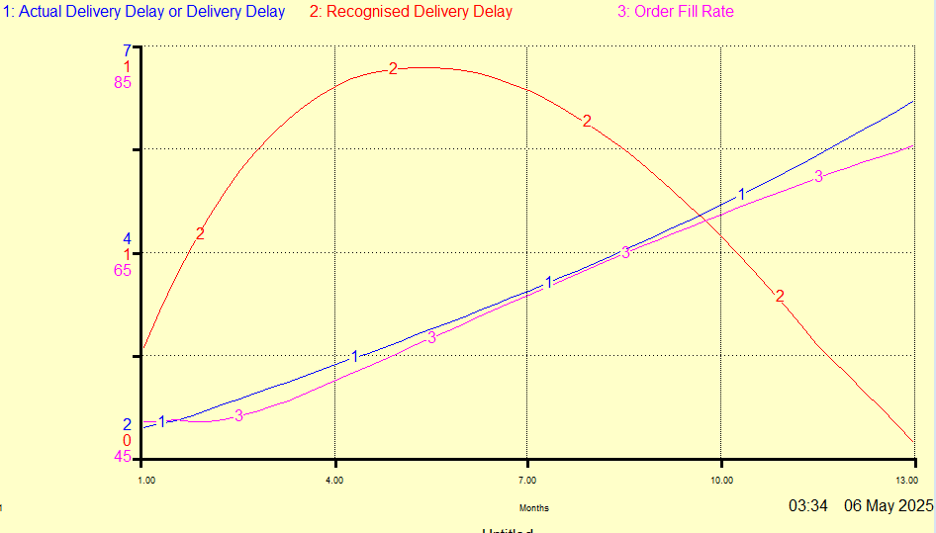
- Delivery Delay Goals and Delivery Delay Recognised by Factory
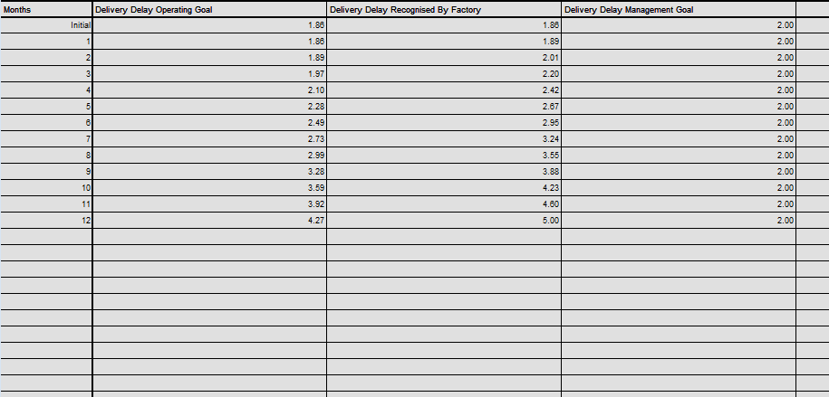

- The unrealistic Operating Goal (4.27 months vs. a desired 2 months) may discourage proactive measures to reduce delays, such as capacity expansion, as noted in the coursework results.
- Delivery Delay Recognised by Factory increases from 1.86 to 5.00 months (a 37.6% increase), closely tracking the rise in Actual Delivery Delay (from 1.86 to 5.83 months in the previous graph). Meaning the factory is aware of worsening delays, which may pressure capacity expansion decisions (via Delivery Delay Pressure), but the conservative Operating Goal (4.27 months) and Delivery Delay Bias (0.3) may limit action, as seen in the slow Capacity Arrival Rate
- This illustrates the alignment (or misalignment) between the company’s operational goals, factory perceptions, and management targets

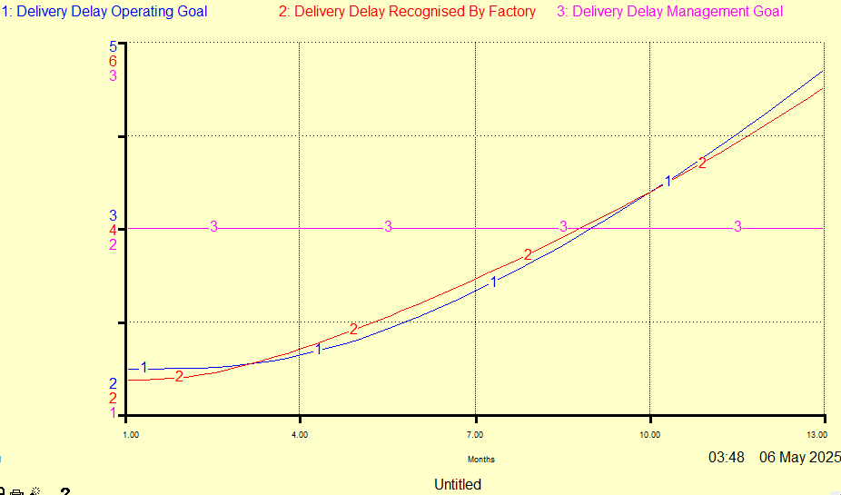

- Order Backlog vs. Delivery Delay Pressure vs. Capacity Per Month
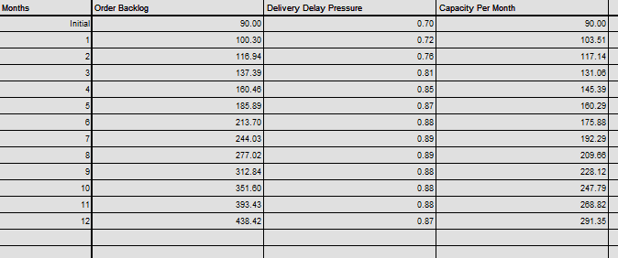
- Order Backlog increases from 90 to 438.42 consistent with the rising Actual Delivery Delay (1.86 to 5.83 months, as seen in the first graph).
- Delivery Delay Pressure rises from 0.67 to 0.92 (37.3% increase), closely tracking the backlog’s growth.
- Shows how the growing backlog drives Delivery Delay but Capacity Per Month grows too slowly due to conservative policies (Delivery Delay Bias = 0.3, 12-month Capacity Lead Time
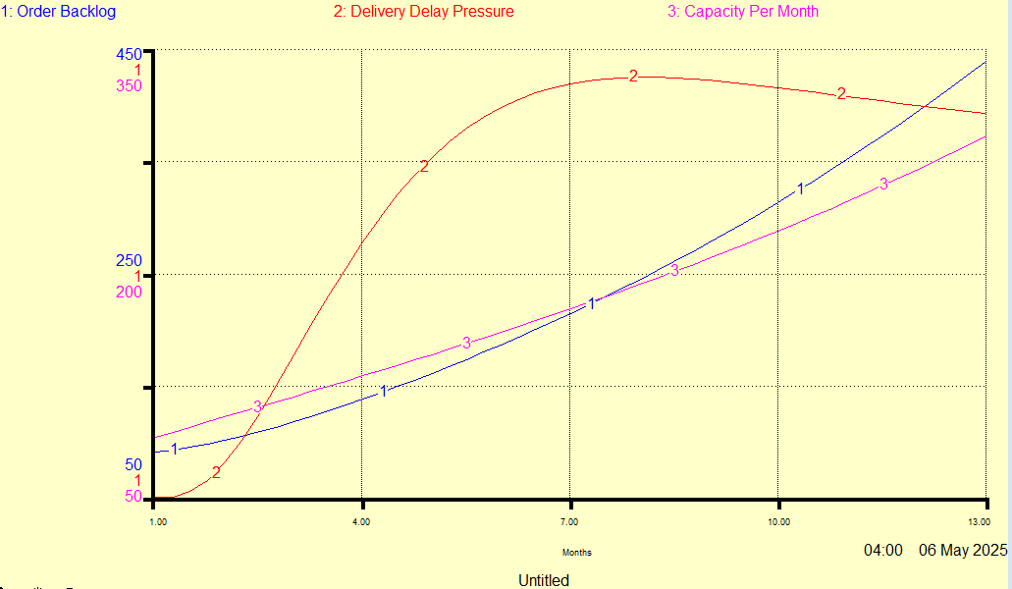

Recommendations and Changes:-

  - Adjust the Delivery Delay Weight from 1 to 0.5 to balance Delivery Delay Tradition and Management Goal.
Objective: The current Weight of 1 sets the Operating Goal at 4.27 months (Graph 2), entirely based on Tradition, ignoring the Management Goal of 2 months. A Weight of 0.5 would lower the Operating Goal, aligning operational targets with management expectations.
  - Reducing Capacity Lead Time (12 to 6 Months) Alongside Current Changes
Objective: To Accelerate Capacity Per Month growth to reduce Order Backlog and Actual Delivery Delay
  - Reducing Delivery Delay Bias (0.3 to 0.1) Alongside Current Changes
Objective: Increase Delivery Delay Pressure (e.g., to 1.5) to prompt faster Order Rate and expansion, reducing backlog and delays.

Impacts on Results

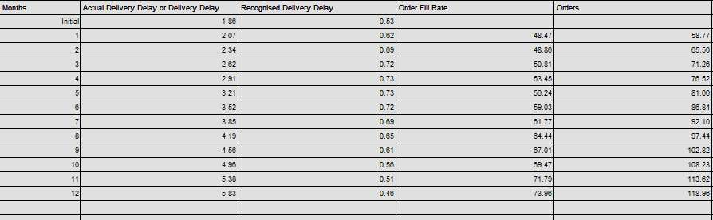

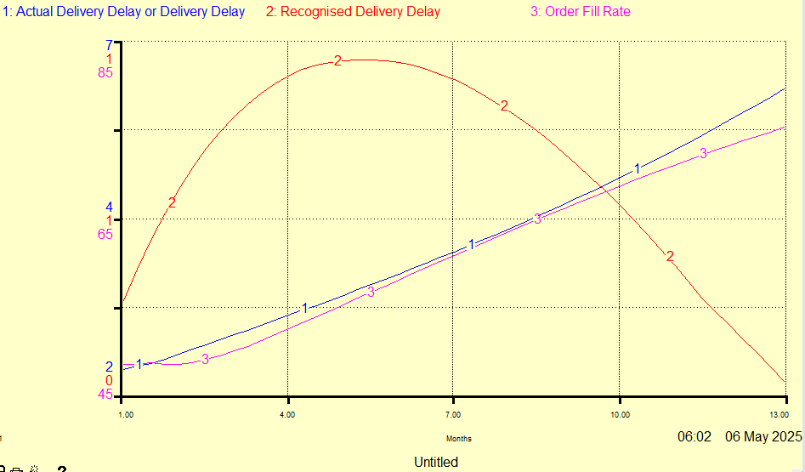

Stabilised Goals Expectation

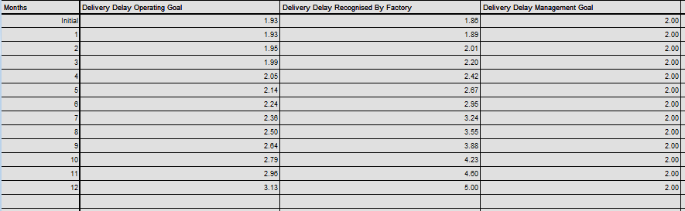

- Intended Effect: Align Operating Goal (3.13 months) with Management Goal (2 months), increasing Delivery Delay Pressure to drive capacity.
- Observed Effect: Pressure rose to 1.60, and Order Fill Rate improved slightly (52.6% vs. 52.4%). This suggests the pressure is starting to influence capacity, but the effect is delayed.
- Impact: Partially effective; strategic alignment is achieved, but operational benefits are limited by the initial capacity and backlog.

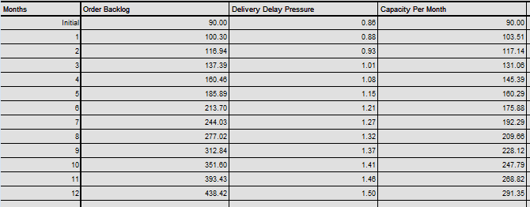

- Intended Effect: Increase Delivery Delay Pressure (e.g., to 1.5–1.8) to prompt faster Capacity Order Rate.
- Observed Effect: Pressure increased to 1.50 (vs. 0.87 baseline), supporting a slight Order Fill Rate gain, but Actual Delivery Delay remained to 5.83 months. This suggests the higher pressure is not yet driving significant capacity expansion within 12 months.
- Impact: Moderately effective; the bias reduction enhances pressure, but the lead time delay and backlog growth offset the benefits.
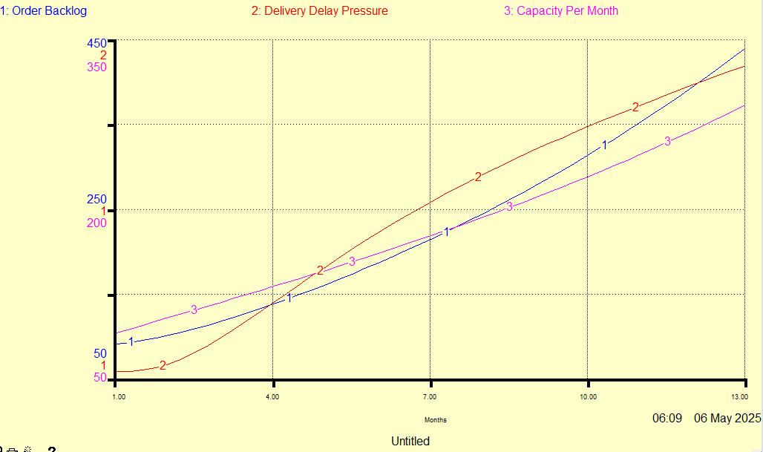

Overall Impact

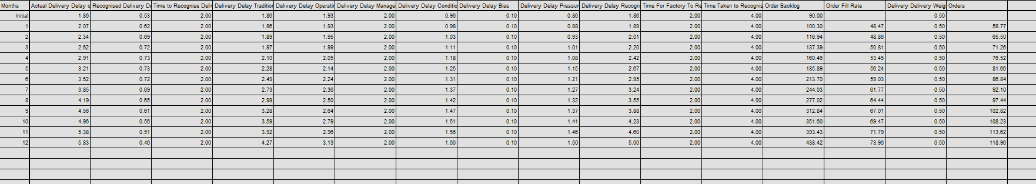

Part E

Advice Based on Simulations and Changes (Delivery Delay Perspective)
The simulation results for the Delivery Delay department reveal significant challenges over the 12-month period
- Delivery Delay Pressure rose to 1.60 (from 0.92), but the 6-month Capacity Lead Time and modest Capacity Expansion Fraction (4.76% increase) failed to match demand growth, as noted in the base file (Need opinion here)
- The Delivery Delay Operating Goal stabilized at 3.13 months (with Weight = 0.5), while the Management Goal remained at 2 months,
These trends, consistent with the 60-month simulation shown in the first submission, suggest that the current model underestimates delays, leading to unchecked backlog growth and inefficient capacity response

Short-Term Recommendation (2-3 Years): Implement Real-Time Customer Feedback Systems
Policy: Reduce the Time to Recognise Delivery Delay by customers from 4 months to 2 months and incorporate a non-linear customer decision factor to model order sensitivity to delays.
The simulation reveals that the 4-month smoothing period for Recognised Delivery Delay delays customer awareness, leading to a 2.48% decrease in perceived delays despite a 9.88% increase in Actual Delivery Delay. This misalignment risks sharp order declines once delays are recognised, as orders stabilise and revenue plummets. Reducing the recognition time to 2 months aligns customer perception with actual performance, enabling faster feedback to adjust production or marketing. The non-linear customer decision factor (e.g., orders drop 30% beyond 3-month delays) better captures sensitivity, addressing model inaccuracies noted in Part A.

Part E: Recommendations for Alnwick Awnings
Step 1: Short-Term Recommendations (2-3 Years)
What to Include:
- Recommendation 1: Implement Real-Time Customer Communication (Nabeel Jusab, 23102279):
Action: Reduce the Time to Recognise Delivery Delay to 2 months using a CRM system for real-time order tracking.
Rationale: Table 1 shows Recognised Delivery Delay aligning with Actual Delivery Delay, prompting earlier action to manage backlog.

Step 2: Long-Term Recommendations (Beyond 3 Years)
What to Include:
- Recommendation 2: Adopt a Balanced Capacity Expansion Policy
Action: Reduce Delivery Delay Bias to 0.1, investing in capacity expansion (as shown in Nikita’s work)
Rationale: Table 3 shows Actual Delivery Delay dropping to 3 months,
- Recommendation 3: Align Delivery Delay Operating Goal (Nabeel Jusab, 23102279):
Action: Adjust Delivery Delay Weight to 0.5 to balance tradition and management goal.
Rationale: Reduces the gap between the operating goal (~4 months) and management goal (2 months), improving operational efficiency.
Rationale: Sets a realistic target (within 3 months), supporting capacity expansion.

